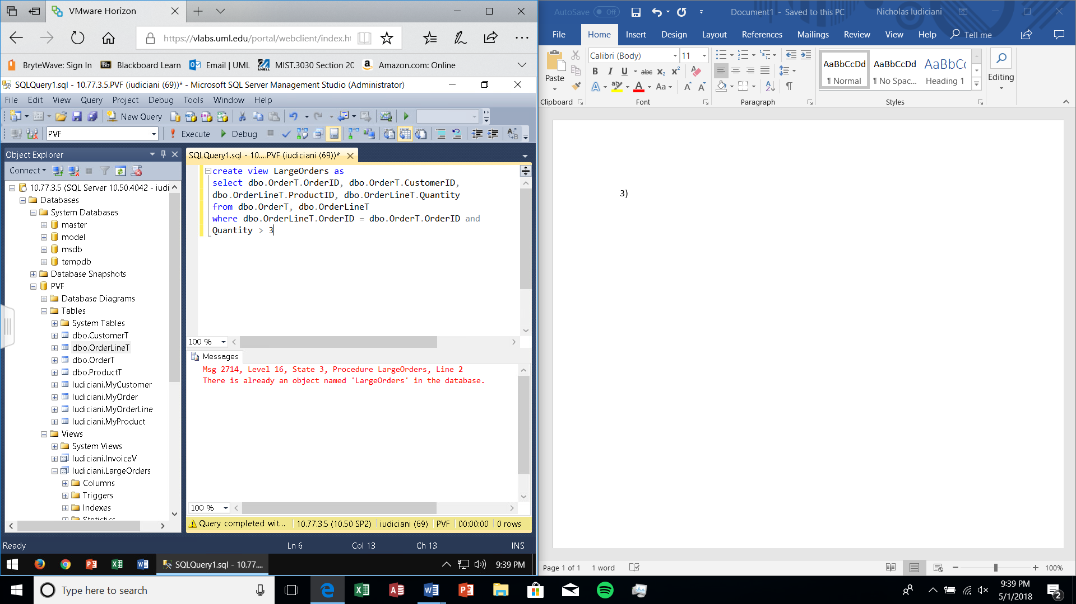3)

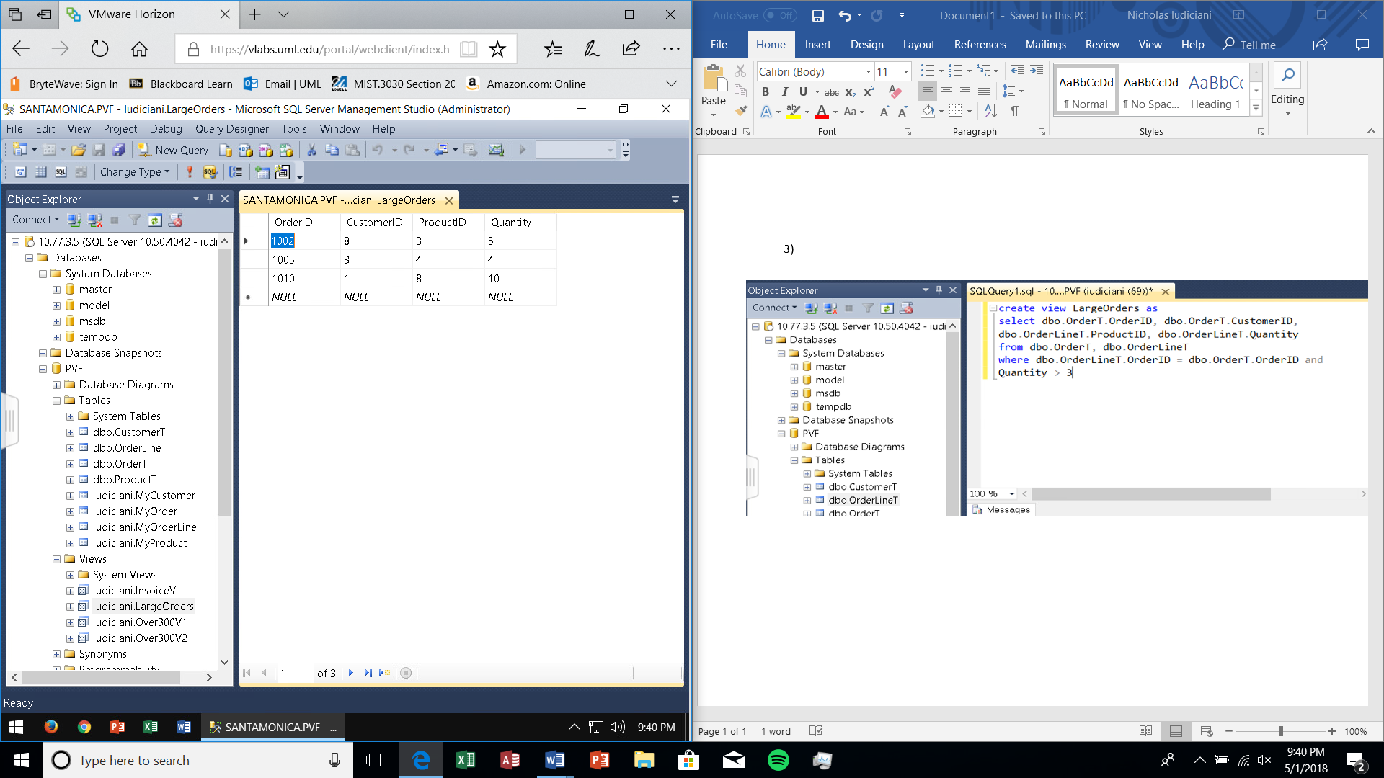

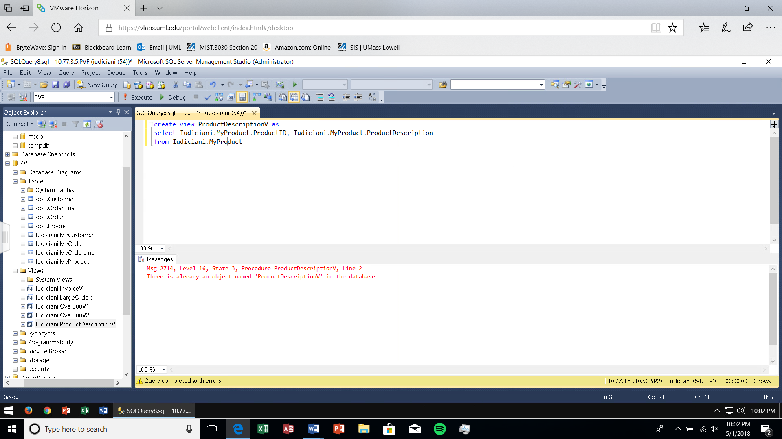4) Creating The View

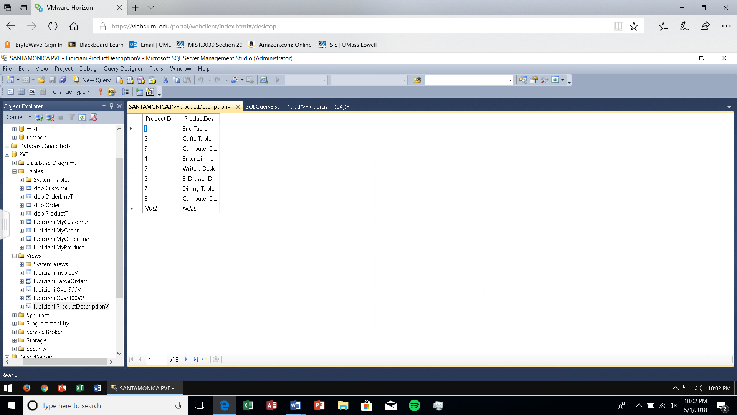

Updating The View

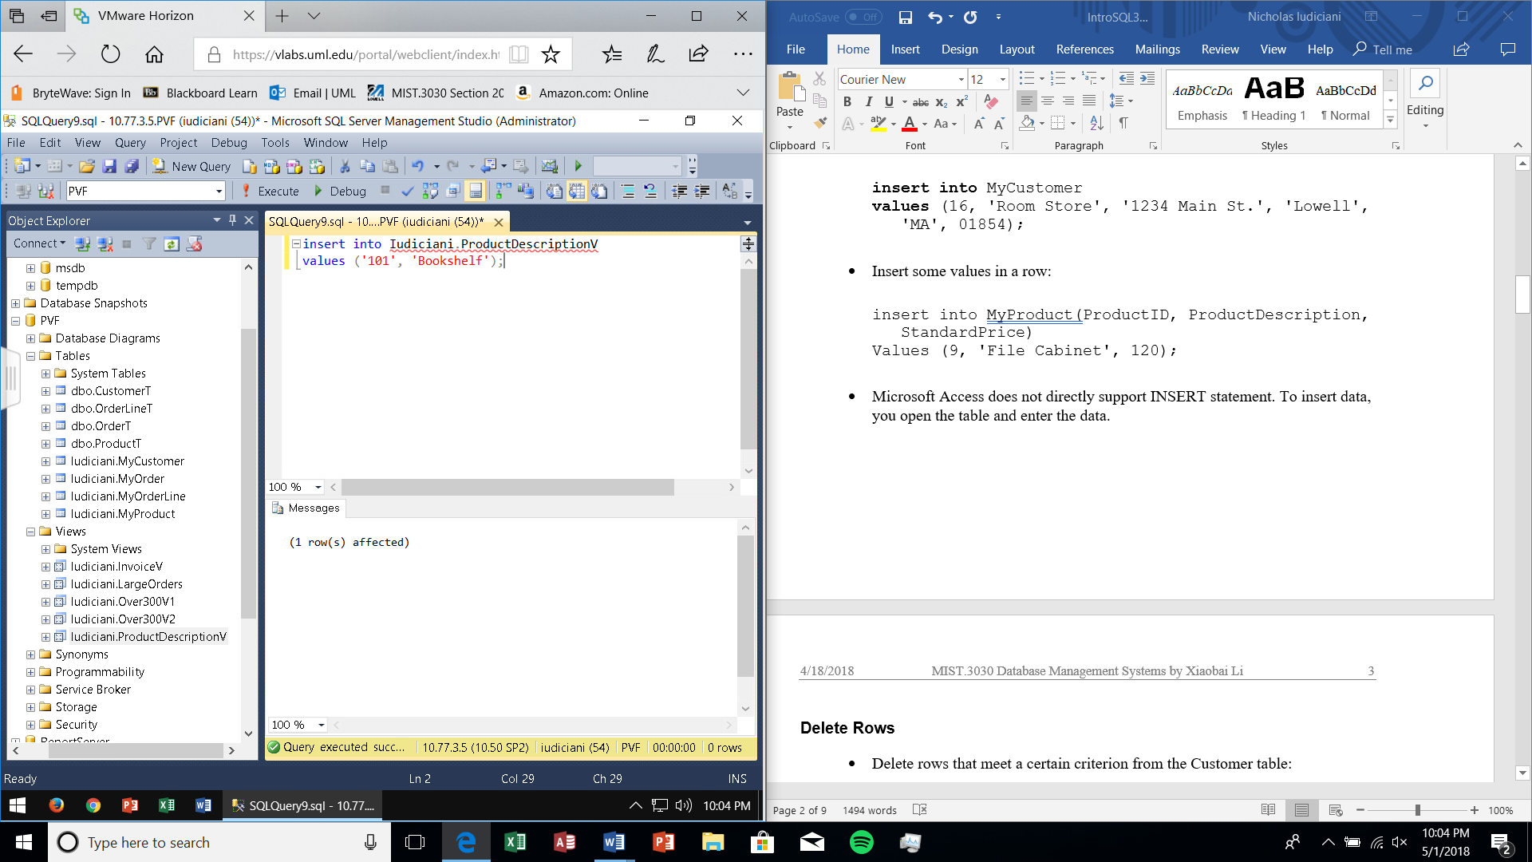

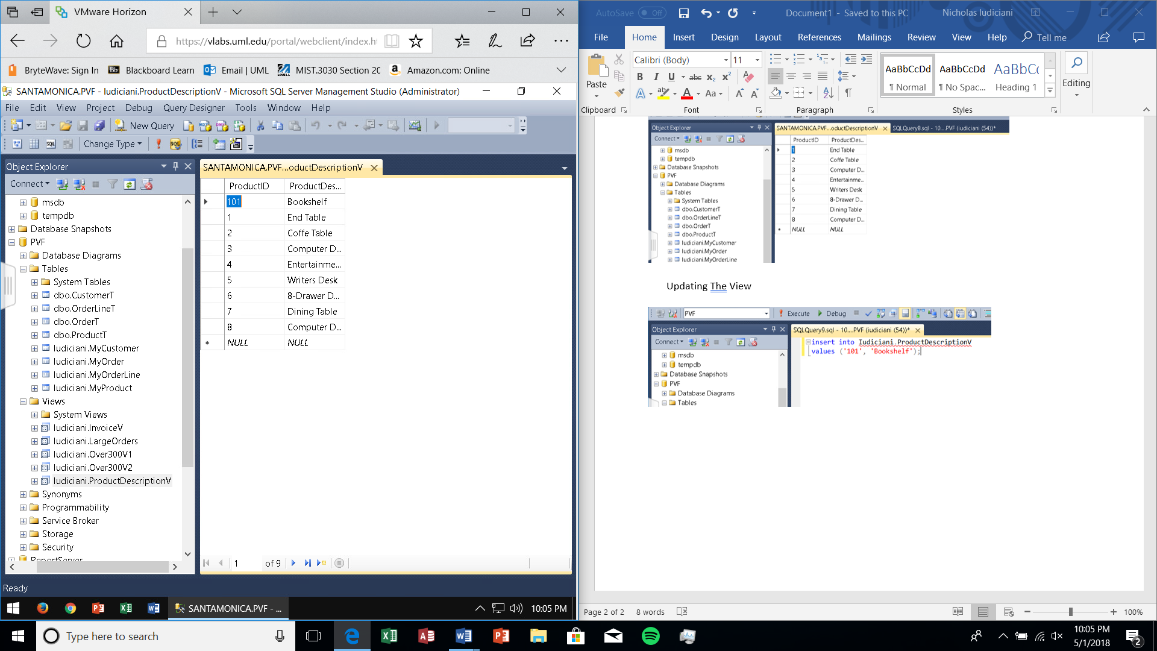

5) I am unable to do #5 as I was unable to maintain contact with a partner. I am a commuter student so I do not stay on campus to coordinate homework, so I had to resort to email. My partner did not receive my emails, nor did I receive their responses. I can do Part a) with ease but part b) won’t have statements or an output.

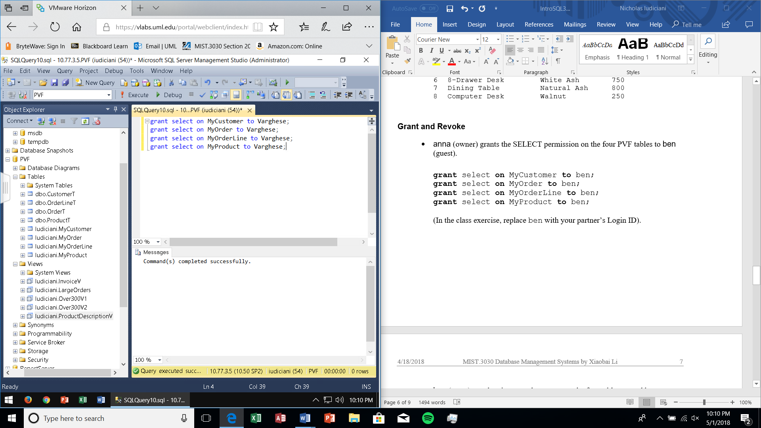a)

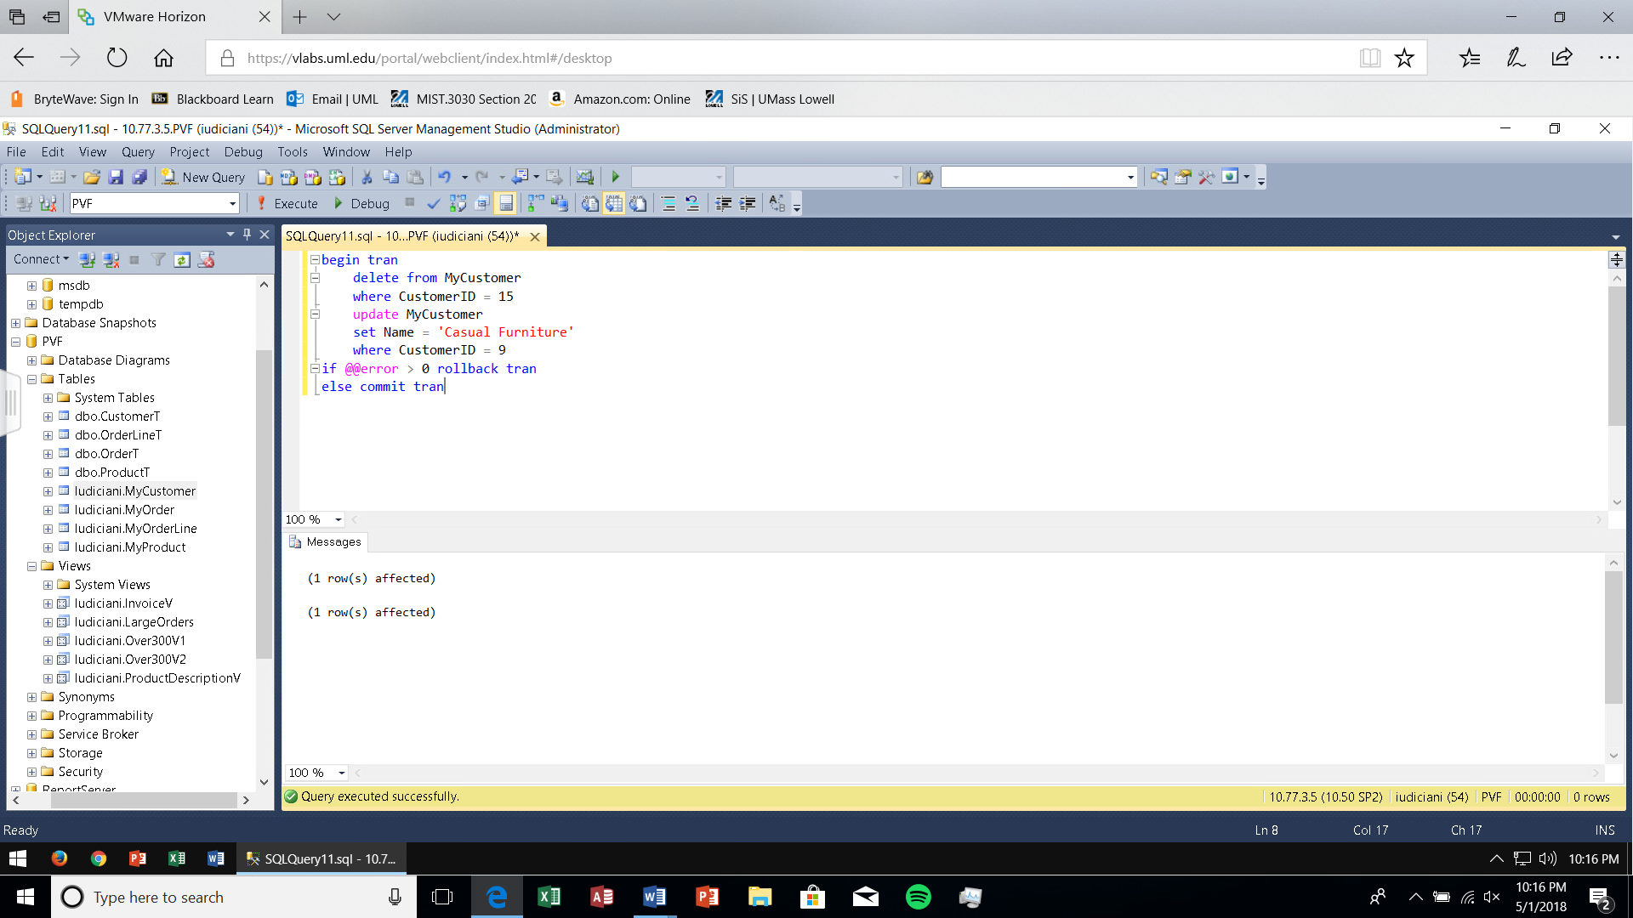6) I used the dbo.CustomerT Table to show what it looked like before the transaction (I executed the transaction first and didn’t show what MyCustomer table looked like before).

